EXP NO 10. Create a Snapshot of a VM and Test it by loading the Previous Version/Cloned VM using virtual box.
AIM:
To create a snapshot of a virtual machine in VirtualBox and test it by loading the previous version or cloned VM.
PROCEDURE:
STEP 1: Open Oracle VirtualBox and start the virtual machine you want to snapshot.
STEP 2: Make some changes inside the VM (e.g., create files on the desktop or install software) to have a test state.
STEP 3: With the VM selected (powered off or running), go to the Snapshots panel → Click Take (or Take Snapshot).
STEP 4: Enter a name and description for the snapshot → Click OK.
STEP 5: To test the snapshot
DESIGN:
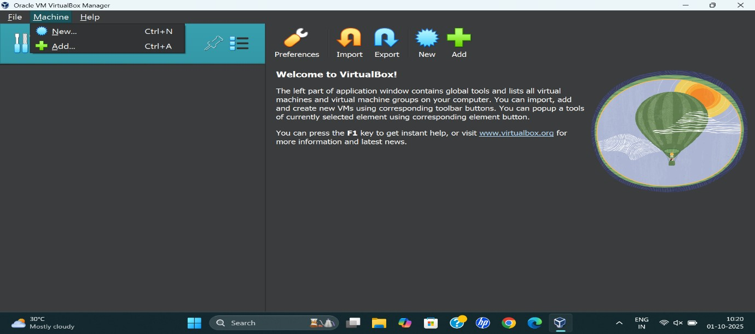

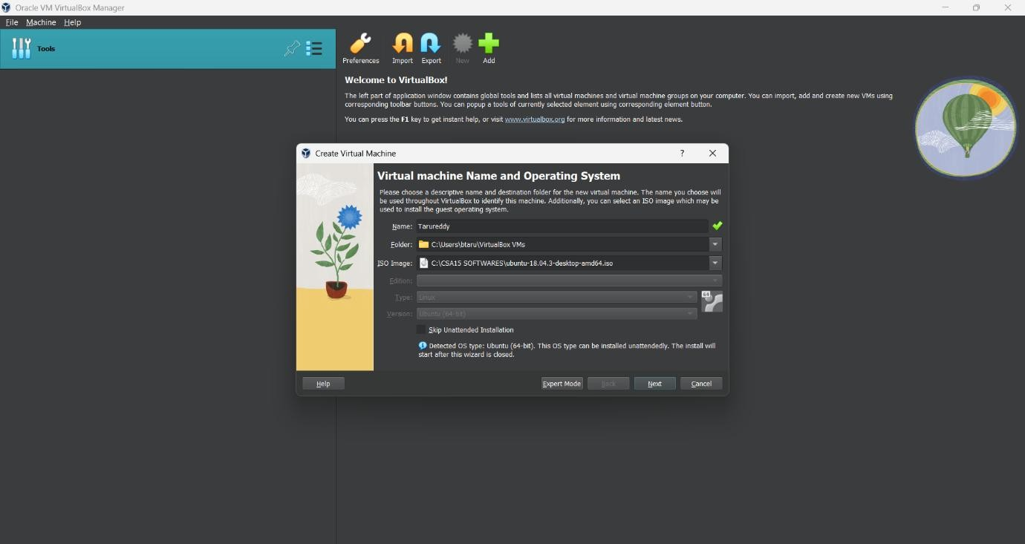

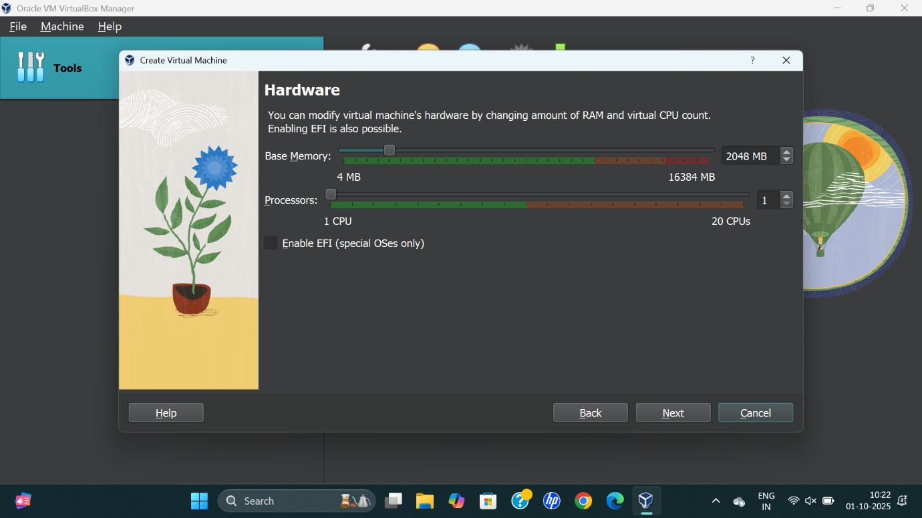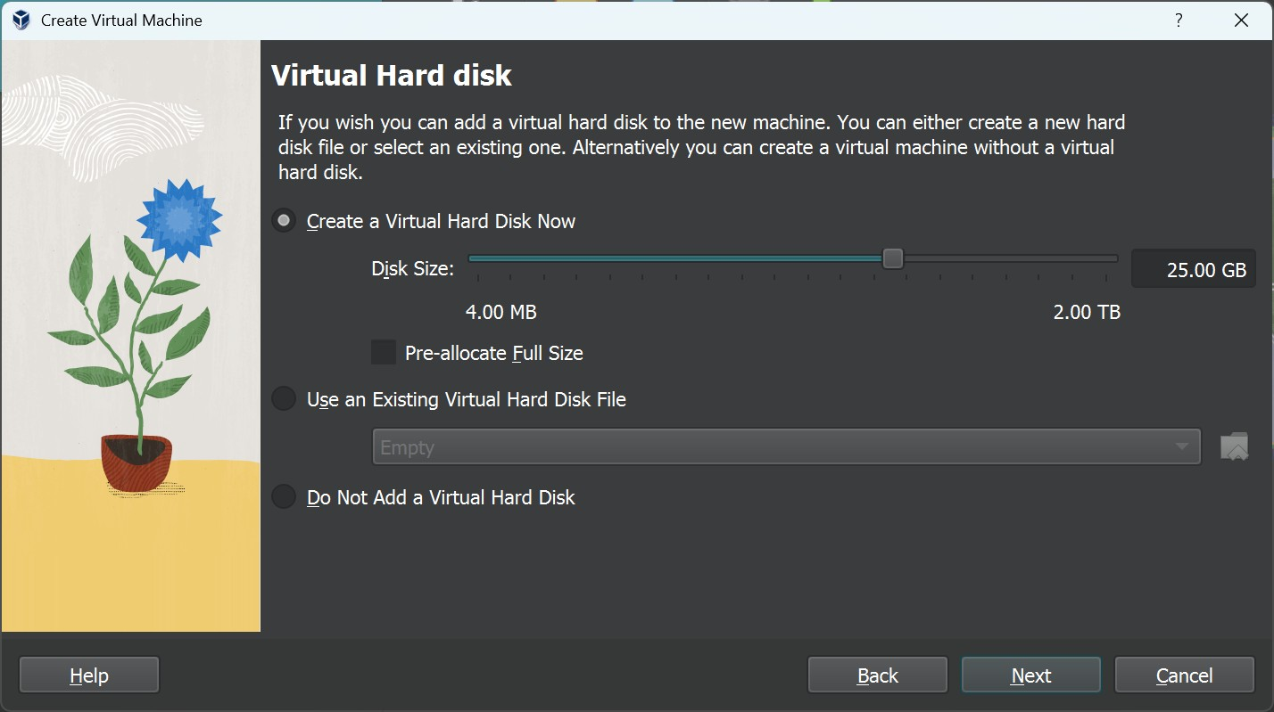
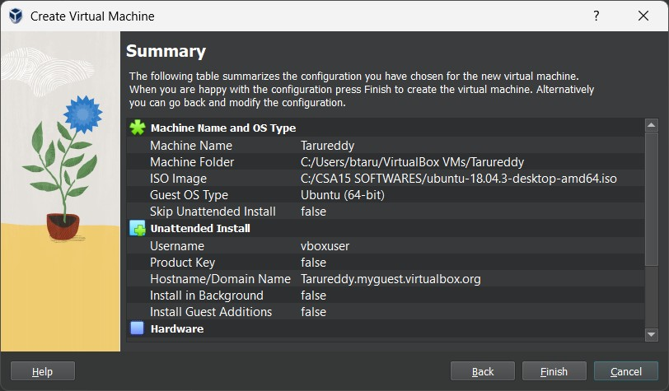

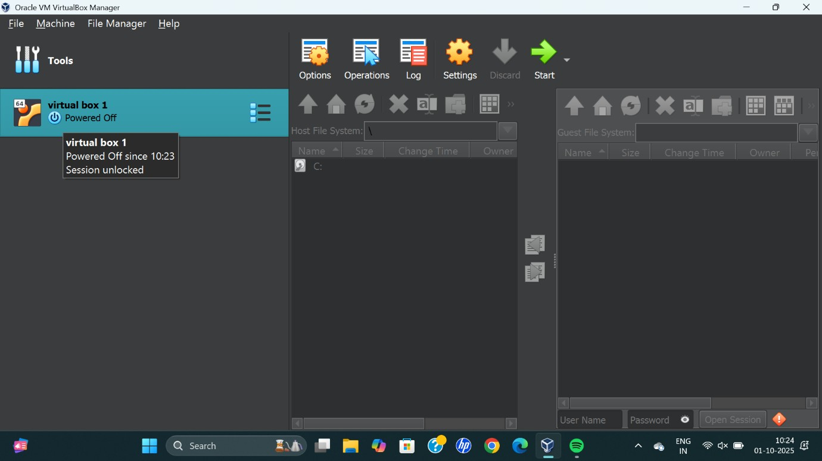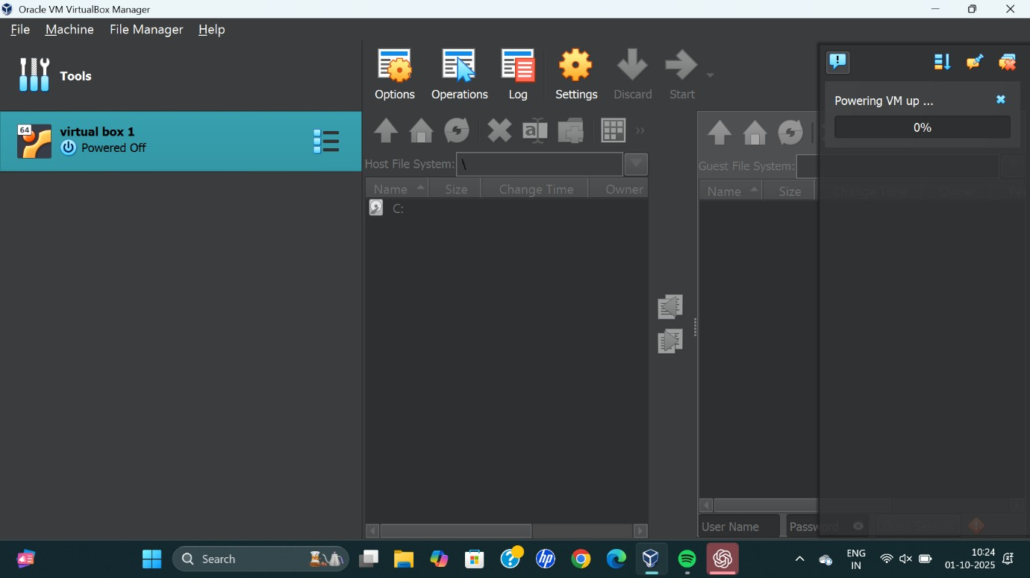

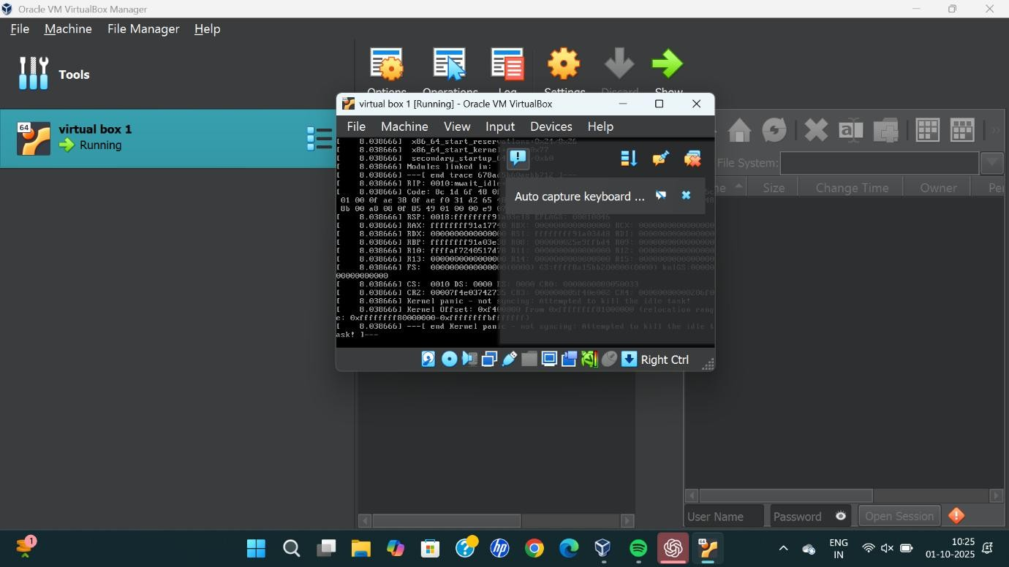

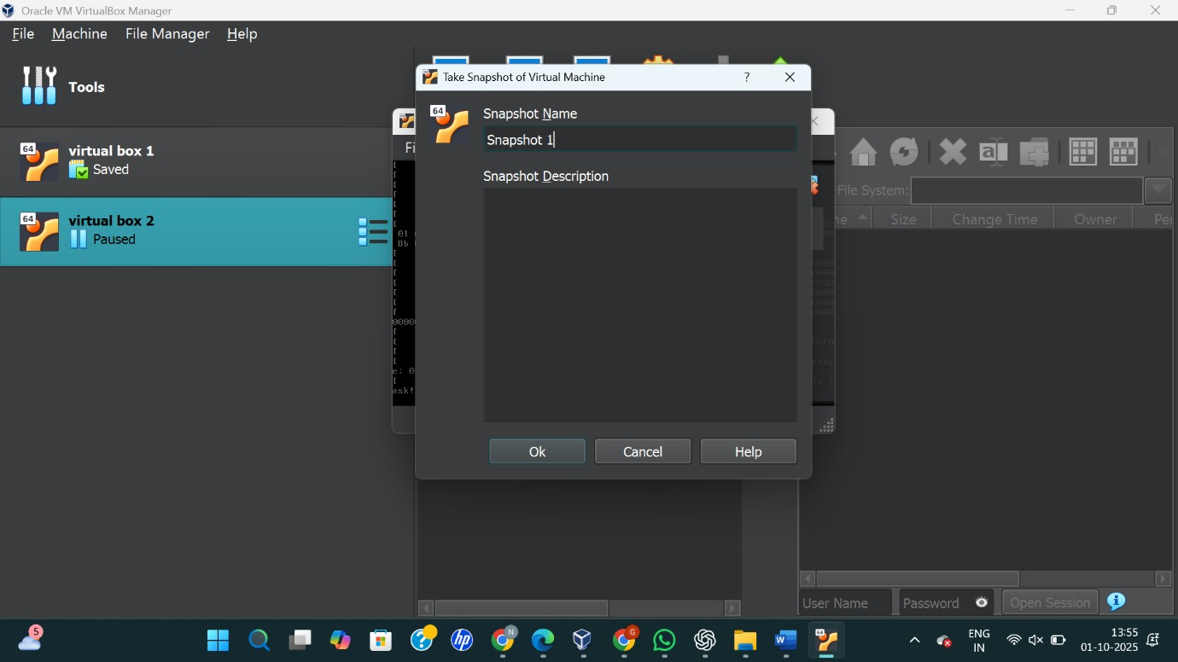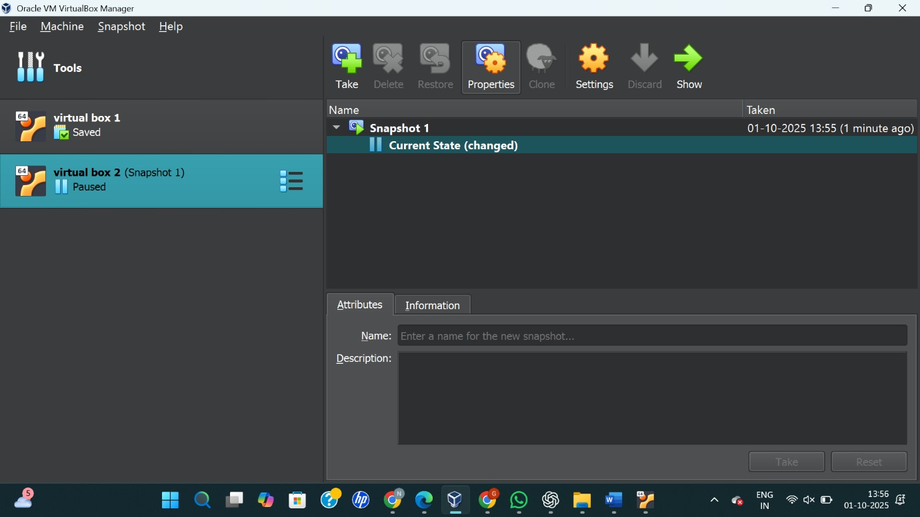

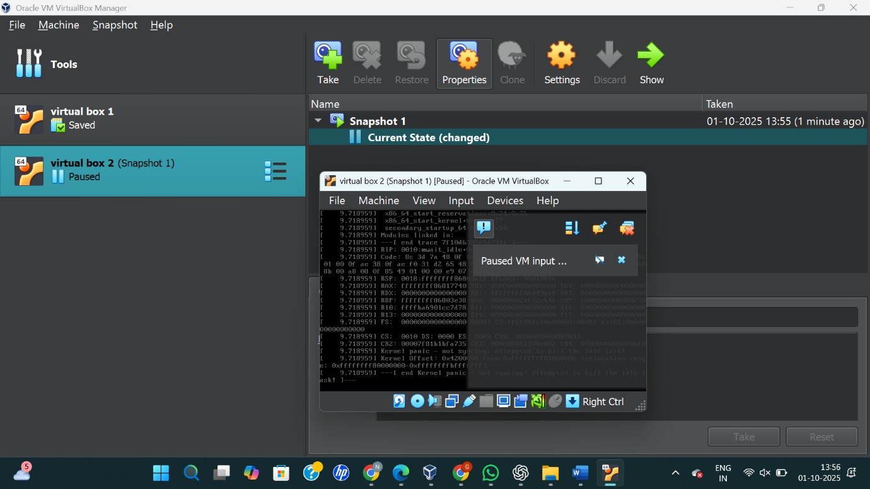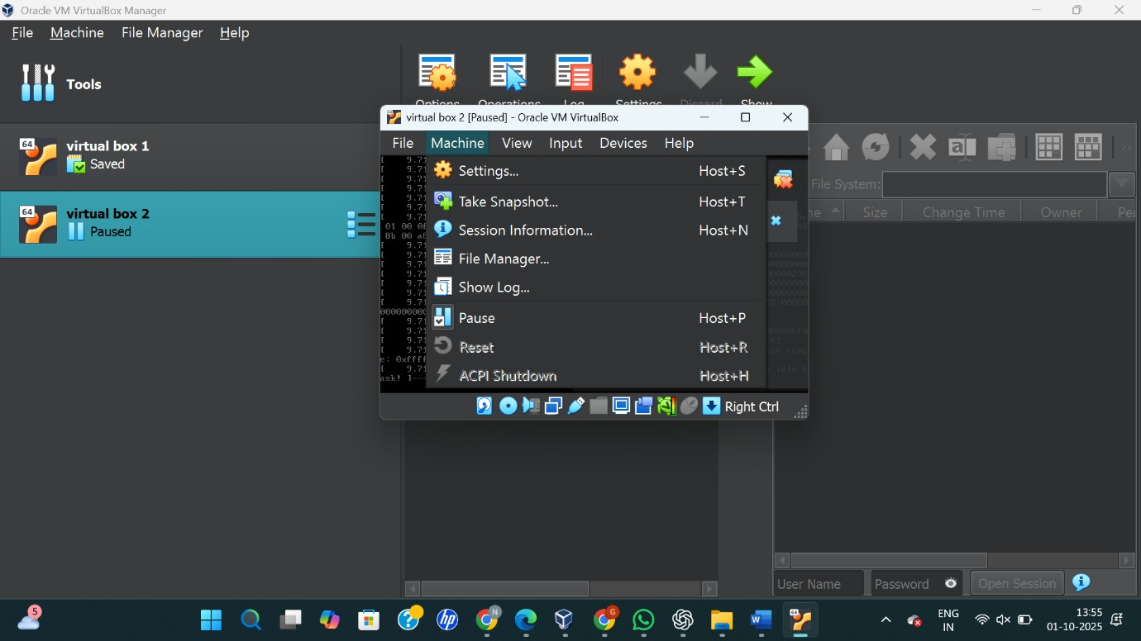
RESULT:
A snapshot of the virtual machine was successfully created and tested by restoring the previous state.

